**For Mail Basic accounts**

In this article, we will show you how to set up your Mail Basic account on your Android smartphone or tablet.

**Please Note**

The following steps were created using a device with Android 10. The designations of the individual menu items may vary slightly for devices from other manufacturers.

* Tap the Settings icon (typically displayed as a **gear**).

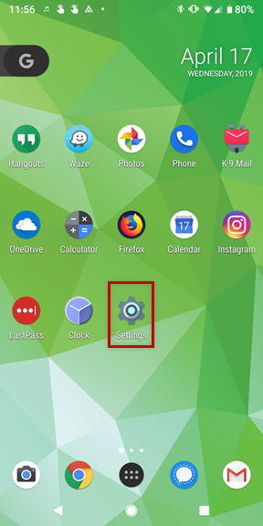

* Go to **Accounts.**

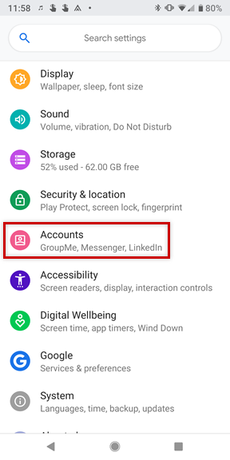

* Tap Add Account.

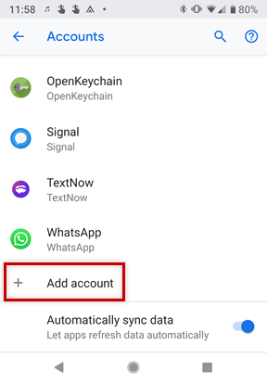

* Select Personal (IMAP).

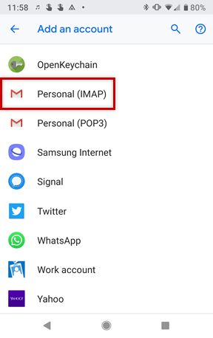

* Enter your email address and tap Next.

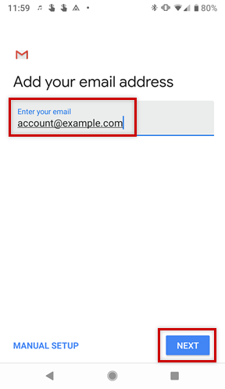

* Enter the password to your email address and tap Next.

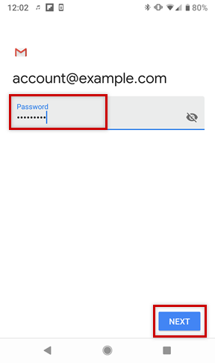

* In the **Server** field, enter **imap.ionos.com** and tap Next.

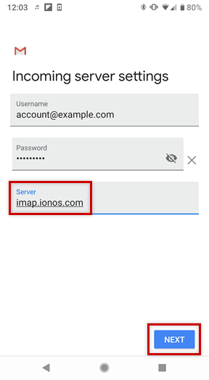

* In the **SMTP Server** field, enter **smtp.ionos.com** and tap Next.

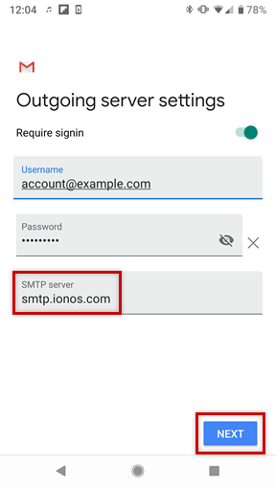

* Choose your desired **Account Options** and tap Next.

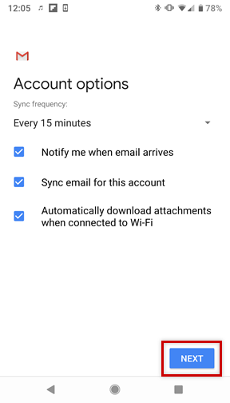

* If you would like, you can change the default **Account Name,** which helps you differentiate this account from other email accounts on your device, or **Your Name**, which is displayed on messages you send. Finally, tap Next to complete the setup process.

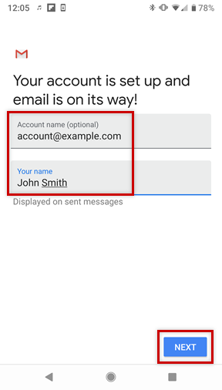

**Please Note**

If you choose to perform a manual setup or would like to use a POP3 account instead, you can find the necessary settings below.

| Incoming Email Server | | |
| --- | --- | --- |
| **Setting** | **For IMAP** | **For POP** |
| Server | imap.ionos.com | pop.ionos.com |
| Security type | SSL | SSL |
| Port | 993 | 995 |

| Outgoing Email Server | |
| --- | --- |
| **Setting** | **Your input** |
| SMTP server | smtp.ionos.com |
| Security Type | TLS (Accept all certificates) |
| Port | 587 |
| Login Requires Checkbox |  |
| Username | The full email address of your IONOS email account. |
| Password | The password you entered when setting up the IONOS email address. |

Your Mail Basic account has been successfully added to your Android device and should be ready to use immediately.